**Model Refinement and Test Submission**

**Report**

**Title - Real-Time Recycling Sorting Using Deep Learning**

**Group no: Group 8**

**Group Members:**

1. Tekia Tekle

2. Firehiwet Zerihun

3. Biniyam Demissew

4. Daniel Alemu

5. Eyob Sisay

6. Haymanot Tamrat

# Model Refinement and Test Submission

## ****1. Model Refinement****

### ****1.1 Objective****

The goal of this phase was to enhance the performance and deployment readiness of multiple deep learning models for the classification and detection of waste materials. This supports the development of a smart recycling system that can automatically identify and sort waste into appropriate categories. Three models were considered: a custom Convolutional Neural Network (CNN), a Vision Transformer (ViT), and YOLOv8. Each was trained, tuned, and evaluated using the TrashNet dataset.

### 1.2 Model Training and Evaluation

* **CNN (Convolutional Neural Network):**
  + Architecture consisted of stacked convolutional layers with max pooling, followed by dense layers.
  + Achieved a validation accuracy of ~78%.
  + Misclassifications occurred between classes with similar visual features, such as cardboard and paper.
* **Vision Transformer (ViT):**
  + Fine-tuned from the pre-trained model vit-base-patch16-224-in21k.
  + Validation accuracy improved to ~80%.
  + Slower inference time compared to CNN and YOLO, but better feature learning.
* **YOLOv8 (You Only Look Once):**
  + Trained for object detection with custom annotations (bounding boxes covering the whole image).
  + Achieved mean Average Precision (mAP50) of 81.5%, with fast inference capability.
  + Best-suited model for real-time deployment.

Each model’s performance was measured using metrics such as accuracy, precision, recall, and confusion matrix analysis. YOLOv8 outperformed the others in both speed and precision.

### ****1.3 Refinement Techniques****

Several strategies were applied to improve model accuracy and robustness:

* **CNN & ViT**:
  + Introduced image augmentation techniques (e.g., flips, zoom, rotation) to diversify training samples.
  + Used dropout layers to prevent overfitting.
  + Fine-tuned ViT using pretrained weights from the vit-base-patch16-224-in21k model.
* **YOLOv8**:
  + Converted the TrashNet dataset into YOLO format with synthetic bounding boxes.
  + Used 640x640 image resolution and synthetic bounding boxes to adapt classification images to object detection.
  + Adjusted the confidence threshold to 0.25.
  + Switched from YOLOv8n to YOLOv8s for better performance.

These changes led to noticeable improvements in model generalization and robustness.

### 1.4 Hyper-parameter Tuning

|  |  |  |  |  |  |
| --- | --- | --- | --- | --- | --- |
| Model | Learning Rate | Optimizer | Epochs | Batch Size | Dropout |
| CNN | 0.0005 | Adam | 20 | 32 | 0.5 |
| ViT | 3e-5 | Adam | 10 | 16 | — |
| YOLOv8 | Auto-optimized | SGD | 10 | 16 | — |

Each model’s training process was monitored, and adjustments were made based on validation loss and accuracy patterns.

### ****1.5 Validation Approach****

* **CNN & ViT**:
  + Used 80/20 training-validation split via Image Data Generator in Keras.
  + Ensured class distribution remained balanced.
* **YOLOv8**:
  + Data was pre-divided into train and val folders as required by YOLO format.
  + Validation metrics included mAP50 and mAP50-95.

Although K-Fold validation was not used due to hardware constraints, results were cross-verified with multiple experimental runs.

### 1.6 Feature Considerations

No handcrafted features were used, as all models relied on raw image data. In deep learning, feature extraction occurs during convolution or self-attention layers. Therefore, no dimensionality reduction was necessary.

## 2.Test Submission Phase

### 2.1 Purpose

This phase tested the best model’s performance on unseen data and ensured it was ready for deployment. YOLOv8 was chosen based on its accuracy, speed, and flexibility for edge deployment and web applications.

### ****2.2 Preparing Test Data****

TrashNet images were used for the test set. Since it lacked bounding box annotations:

* Synthetic annotations were generated assuming the entire image contains the object.
* Each label used the format: class_id 0.5 0.5 1.0 1.0, representing a centered bounding box covering the whole image.

### 2.3 Final Model Testing

* YOLOv8 was applied on the test set using the Ultralytics interface:

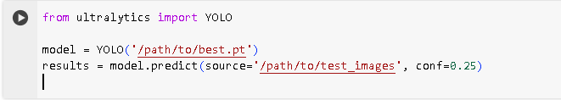

* Results were visualized:

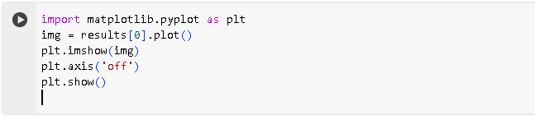

**2.4 Test Metrics**

|  |  |
| --- | --- |
| Metric | Value |
| mAP50 | 81.5% |
| mAP50-95 | 79.7% |
| Precision | 71.3% |
| Recall | 75.0% |

YOLOv8 maintained strong detection accuracy across all waste categories, confirming it was generalizing well.

**2.5. Model Deployment**

The final model was saved and exported:

**C:\Users\Administrator\Desktop\saving model.PNG**

A demo web interface was created using Streamlit. The app allowed users to upload an image and see predictions, using pyngrok for public access in Colab. This shows readiness for real-world deployment (e.g., smart bins, kiosks).

### 6.1. Code Implementation

code snippets for both model refinement and test submission phases.

Convert TrashNet for YOLOv8 Training

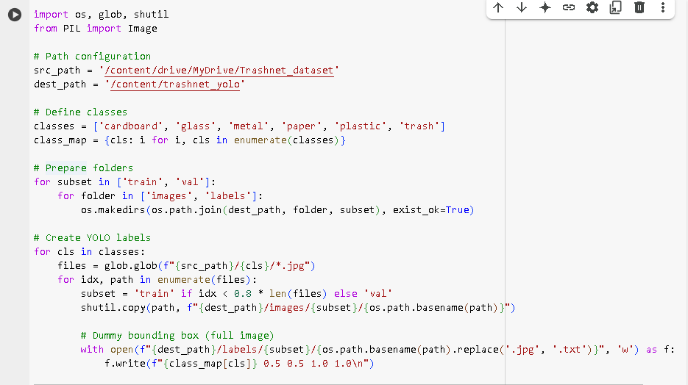

YOLOv8 Training

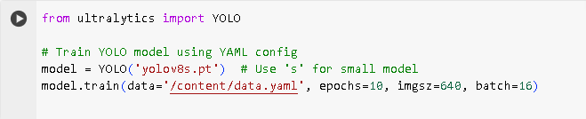

## Conclusion

By refining and testing CNN, ViT, and YOLOv8 models, we determined that YOLOv8 provides the best combination of accuracy and speed for recycling applications. The system is confirming its usability in smart recycling systems. With further enhancements, it can be deployed in real-world scenarios to support sustainable waste management aligned with SDGs.

# References

|  |  |
| --- | --- |
| [1] | A. Lakhouit, "Revolutionizing urban solid waste management with AI and IoT: A review of smart solutions for waste collection, sorting, and recycling,Results in Engineering," vol. 25, 2025. |
| [2] | Q. Y. X. Z. Q. B. J. S. X. L. Qiang Zhang, "Waste image classification based on transfer learning and convolutional neural network,Waste Management," vol. 135, pp. 150-157, 2021. |
| [3] | M. E. C. M. S. B. I. M. N. A. S. F. S. M. H.-M. M. N. M. E. M. A. K. S. B. A. K. A. A. Adiba Tabassum Chowdhury, "Intelligent waste management: a comprehensive review of machine learning and deep learning applications in advanced recycling," 2025. |
| [4] | A. S. A. K. E. M.-w. S. L. R. K. Asmae El jaouhari, "Turning trash into treasure: Exploring the potential of AI in municipal waste management - An in-depth review and future prospects,," vol. 373, 2025. |
| [5] | "Tomra’s AI-powered sorting technology: Revolutionizing recycling: Revolutionizing recycling," 2023. [Online]. Available: https://www.tomra.com. |
| [6] | P. S. M. i. b. c. f. w. m. Dhanashree Vipul Yevle, "Artificial intelligence based classification for waste management: A survey based on taxonomy, classification & future direction," vol. 56, 2025. |
| [7] | F. I. M. N. M. C. M. &. R. M. Sayem, "robust deep learning-based approach for classification and detection. Neural Computing and Applications," *Enhancing waste sorting and recycling efficiency,* vol. 45, 2025. |
| [8] | M. M. A. M. S. M. M. K. N. M. R. A. E. O. S. D. A. S. Z. Fatma S. Alrayes, "Waste classification using vision transformer based on multilayer hybrid convolution neural network,Urban Climate,," vol. 49, 2023. |
| [9] | I. D. A. P. A. F. M. S. N. Alam Rahmatulloh, "Deep Learning Model for Real‐time Identification of Various Types of Waste,Cleaner Waste Systems," vol. 10, 2025. |
| [10] | " What a Waste 2.0: A Global Snapshot of Solid Waste Management to 2050.," 2018. [Online]. Available: www.worldbank.org/en/publication/wdr2018. |
| [11] | T. a. Yang, "kaggle," 2016. [Online]. Available: https://www.kaggle.com/search?q=TrashNet. |
| [12] | S. Sekar, "waste classification data," [Online]. Available: https://www.kaggle.com/datasets/techsash/waste-classification-data. |
| [13] | R. a. K. Ş. R. a. K. M. a. H. M. Aral, "Classification of TrashNet Dataset Based on Deep Learning Models," 2018. |
| [14] | L. a. X. W. Bohong, IEEE International Conference on Electrical Engineering, Big Data and Algorithms (EEBDA), 2022, pp. 784-788. |
| [15] | K. A. a. M. {. D. a. A. K. a. S. Dubey, "Artificial intelligence and IoT driven system architecture for municipality waste management in smart cities: A review," vol. 36, 2024. |
| [16] | H. H. a. C. A. a. B. Youssef, "Machine Learning For the Future Integration of the Circular Economy in Waste Transportation and Treatment Supply Chain," vol. 55, 2022. |
| [17] | M. a. H. A. a. Z. M. a. Z. A. a. C. L.-C. Sandler, "MobileNetV2: Inverted Residuals and Linear Bottlenecks," 2018. |
| [18] | M. T. a. Q. V. Le, "EfficientNet: Rethinking Model Scaling for Convolutional Neural Networks," 2019. |
| [19] | C. K. T. M. Shorten, "A survey on Image Data Augmentation for Deep Learning," 2019. |
| [20] | J. D. S. G. R. &. F. A. Redmon, "You Only Look Once: Unified, Real-Time Object Detection.," *In Proceedings of the IEEE Conference on Computer Vision and Pattern Recognition (CVPR).,* p. 779–788, 2016. |
| [21] | B. Kinge, "Dry and Wet Waste Dataset," 2020. [Online]. |
| [22] | "Recycling Waste Classification Dataset," 2021. [Online]. Available: https://www.kaggle.com/datasets/techsash/waste-classification-data. |